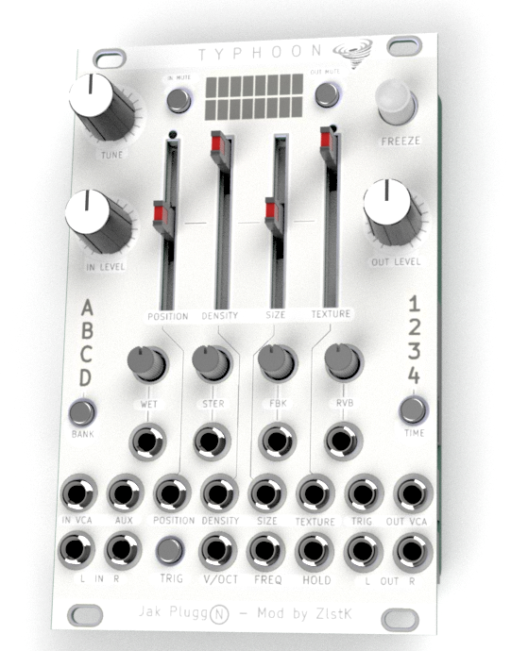

TYphoon - Clouds
Superparasite
Consolidated Manual V 1.1

Overview
This Document is a compilation of the documentation of these differents version of Clouds and the work of other people:
Original Clouds by Emilie Gillet : https://pichenettes.github.io/mutable-instruments-documentation/modules/clouds/manual/#
Supercell : https://grayscale.info/supercell/
Microcell : https://microcell.cc/
Capital-G : https://github.com/capital-G/typhoon-manual
Clouds is a granular audio processor. It creates textures and soundscapes by combining multiple overlapping, delayed, transposed and enveloped segments of sound taken from an audio recording buffer.
Clouds differs from other granular Eurorack modules in that it focuses on the real-time processing of audio sources from your modular system itself, rather than the playback of pre-recorded samples from a storage device. It rewards the freezing, fragmentation and dissolution of the unexpected instant, rather than the careful planning of what might very well not come.
(Source – Original Clouds Manual by Emilie Gillet)

Typhoon is an iteration of differents versions of the original Clouds module by Emilie Gillet.
Clouds ->Supercell -> Microcell Clouds -> µBurst -> Moonsoon -> TYPHOON
Typhoon offer extra controls and mods comparing to original Clouds.
It use the Superparasite firmware. (see https://github.com/patrickdowling/superparasites for more details).
Superparasite include all the regular Clouds modes, all the Parasites modes, and Kammerl Beat Repeat and Spectral Clouds modes.

Mode 1 [●○○○]: Granular Clouds (Parasites)
Mode 2 [○●○○]: Pitch Shift / Time Stretch (Parasites)
Mode 3 [○○●○]: Looping Delay (Parasites)
Mode 4 [○○○●]: Spectral Processor (Parasites)
Mode 5 [○●●●]: Oliverb (Parasites)
Mode 6 [●○●●]: Resonestor (Parasites)
Mode 7 [●●○●]: Beat Repeat (Kammerl)
Mode 8 [●●●○]: Spectral Clouds (Kammerl)

General Settings and functionnality

Supercell - Simplified Time/Quality UI
Tap the TIME switch to cycle between 1, 2, 4, or 8 seconds of sampling time.
The LED associated with the chosen time value will blink until the buffer has been filled with new material. Note that the sample rate also changes in relation to the sampling time.
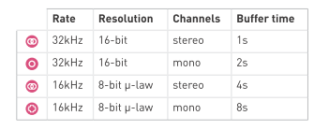
Alternate Modes
Hold the TIME switch to see which mode is currently active and tap TIME to select a new mode.
If the default Supercell firmware is installed, the 1/2/4/8 LEDs will correspond to the Granular Processor, Pitch Shifter, Looping Delay, and Spectral Madness modesfrom Clouds, respectively.
To exit without changing modes, wait five seconds and the mode selection process will automatically exit. The LED of the selected mode will blink ten times before selection is canceled.
Microcell - Calibration Procedure:
1. Patch a cable from any DC offset source or MIDI-to-CV module into the V/OCT input (not the Pitch input).
2. Power on your modular system while holding the TRIG switch. The input VU meter will start to blink.
3. Send a 1V DC offset into the module. Many Eurorack modules can generate DC offsets but you will need some way to measure the voltage. Use a digital multimeter or an oscilloscope module like the Mordax DATA to generate precise values. Alternately, use your MIDI-to-CV module and play a C2 note. When the 1V signal is present at the V/OCT input, press the TRIG switch.
4. The output VU meter will now start to blink. Change the 1V DC offset to 3V instead (or play C4 on your MIDI-to-CV module), then press the TRIG switch once more. The calibration process will exit and the module will return to normal operation.
Supercell - Exponential and Linear Pitch Control
The PITCH parameter is now controlled by two separate CV inputs.
The V/OCT input is exponential and the Pitch input is linear (with an attenuverter).
When both inputs are used, the two voltages are summed.
Supercell - Trigger Switch
Clouds had a trigger/gate input for generating individual grains.
Supercell adds a manual TRIG switch that performs the same function.
It’s particularly useful with some of the alternate firmware modes such as Beat Repeat.
This switch isalso used for the quick reload function and adjustment of the internal random voltage generator’s clock rate. See the notes above for details
Supercell - Expanded Modulation Options
Each of the nine granular processing parameters has its own CV input with an inverting attenuator (attenuverter) to set the level and polarity of external CVs.
Along with patching external CVs directly to each CV input, you may want one CV to affect multiple parameters without using splitter cables or a multiple module. Patch a CV signal into AUX and it will be distributed to all nine of the parameters.
The attenuverters can still be used to control the modulation depth of this distributed CV signal. Patching a different signal directly into one of the nine CV inputs will disconnect the AUX signal from that parameter.
Supercell - Internal Modulation
There is a third option for modulation, which involves a fluctuating random CV that is internally generated by the module itself. Any unpatched parameter inputs will receive this signal automatically (assuming that the AUX input is also unpatched, because patching into AUX overrides this internal random CV). The attenuverters control the modulation depth here as well.
> To prevent the internal modulation from changing a parameter, set the attenuator to its center position.
> To change the frequency of the random CV changes. Press and hold the TRIG switch and then turn the PAN knob until the HOLD LED starts to blink. The randomization frequency will change when the TRIG switch hold is released. Return the Pan knob to its original position if needed.
>The available range is from 1 Hz to 100 Hz.
> To disable the internal random CV, press both of the mute switches for about two seconds. > When the modulation, is activated you can see a visual activity on the four slider pots of Typhoon

Supercell - Simplified Load/Save UI
To load saved presets, tap the BANK switch to step through the four memory banks.
Note that a brand new module (or a module that has just received a firmware upgrade) will have four empty banks.
A new feature has also been added which reloads the current preset bank without cycling through the other three banks first, which may be useful in live performance settings. Press BANK while pressing TRIG to reload.
To save the current audio buffer, press BANK for one second to begin the save process.
Save into the current bank by pressing BANK again for one second.
Alternately, you can select a different bank to save into by tapping BANK briefly before saving.
The save process will exit after saving is complete. Alternately, the save process will be canceled if nothing is saved within five seconds.
The LED of the last-selected bank will blink ten times before saving is canceled.
Microcell - attenuation feature :
- Press and hold the TIME switch, then turn a knob within 3 seconds (otherwise you enter the mode selection UI).
The knob now functions as an attenuator for that parameter's CV input.
The attenuation value is saved when you release the TIME switch hold.
Turning other knobs before releasing the switch hold will adjust their attenuation values too.

- Press and hold the BANK switch, then turn a knob within 3 seconds (otherwise you enter the preset saving UI).
This works as described above, but the knob functions an inverting attenuator.
With the knob turned to left of center incoming CVs with be attenuated *and* inverted, while values to the right of center will only be attenuated.
This function works for all nine of the DSP parameters.
It does not work for the analog Input and Output VCAs.
It does however mean that the internal randomization feature can be used more effectively.
Just enable the randomization (press and hold the In and Out mute switches for 5 seconds), then set the attenuation values.
Stereo Input/Output VCAs
The inputs and outputs now include stereo VCAs and separate VU meters. The knobs for Input and Output function as DC offsets for their respective VCAs, setting the modulation baseline when the VCA inputs are patched, so turn these knobs to their minima if you want to use unipolar CV sources like envelopes. CV signals affect the left and right channels equally. If you prefer to modulate the left and right channels separately, this can be accomplished with external VCAs.
License
cc-by-sa 3.0
Mutable Instruments Manual: cc-by-sa 3.0
Kammerl: MIT License
Parasites: MIT LIcense
Superparasites: MIT License

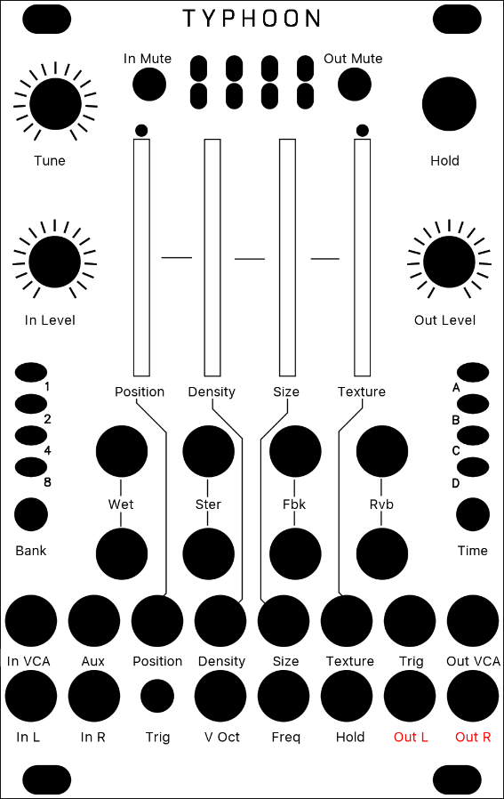
Mode 1 [●○○○]: Granular Clouds (Parasites)
Source: mqtthiqs Parasites

Original Button | Parameter | Description
Position | Position | Selects from which part of the recording buffer the audio grains are played. Turn the knob clockwise to travel back in time.
Density | Density | At 12 o’clock, no grains are generated. Turn clockwise and grains will be sown randomly, counter-clockwise and they will be played at a constant rate. The further you turn, the higher the overlap between grains.
Size | Size | At 12 o’clock, the buffer is played at its original frequency.
Texture | Texture | Morphs through various shapes of grain envelopes: square (boxcar), triangle, and then Hann window. Past 2 o’clock, activates a diffuser which smears transients.
Wet | Wet | Dry/wet balance
Stereo | Stereo | Stereo spread (amount of random panning/balance applied to the grains).
Feedback | Feedback | Feedback amount.
Reverb | Reverb | Reverberation amount.
Freeze | Freeze | This latching button stops the recording of incoming audio. Granularization is now performed on the last few seconds of audio kept in memory in the module. When the input gate signal is high, stops the recording of incoming audio, just as latching the FREEZE button would do.
Trigger | Trigger | Generates a single grain. By moving the grain DENSITY to 12 o’clock, and sending a trigger to this input, Clouds can be controlled like a micro-sample player. An LFO or clock divider (or even a pressure plate) can thus be used to sow grains at the rate of your choice.
Input Level | In Level | From -18dB to +6dB.
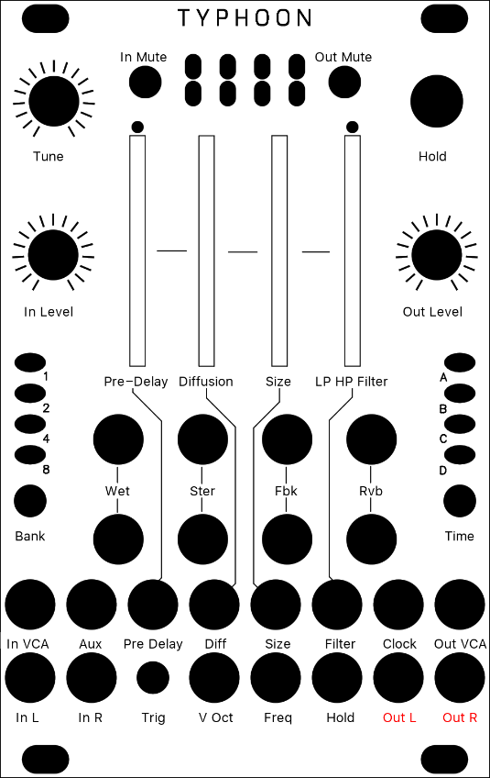
Mode 2 [○●○○]: Pitch Shift / Time Stretch (Parasites)

This mode is quite similar to the granular mode, except that it uses two overlapping grains synchronized with the most salient period of the sound. The grains are carefully spliced so that they mesh well with each other (a technique similar to the “deglitching” of early pitch-shifters).
Source: mqtthiqs Parasites

Original Button | Parameter | Description
Position | Pre-Delay | Modulating POSITION when recording is frozen will “scrub” through the audio buffer. Clouds’ uses classic time-domain methods which are not suitable for polyphonic or percussive material (unless this percussive material is breakbeats and you liked Akai samplers. Then: smile).
Density | Diffusion | Creates a granular diffusion effect based on all-pass filters.
Size | Size | Controls the size of the overlapping windows used for pitch-shifting and time-stretching – from an extremely grainy “drilling” sound to smooth bits of loops.
Texture | LP/HP Filter | Acts as a low-pass/high-pass filter.
Trigger | Trigger | Sending a trigger to the TRIG input creates a clock-synchronized loop (when FREEZE is enabled) or stuttering effect – equivalent to applying a tempo-synchronized decaying envelope on the POSITION parameter.

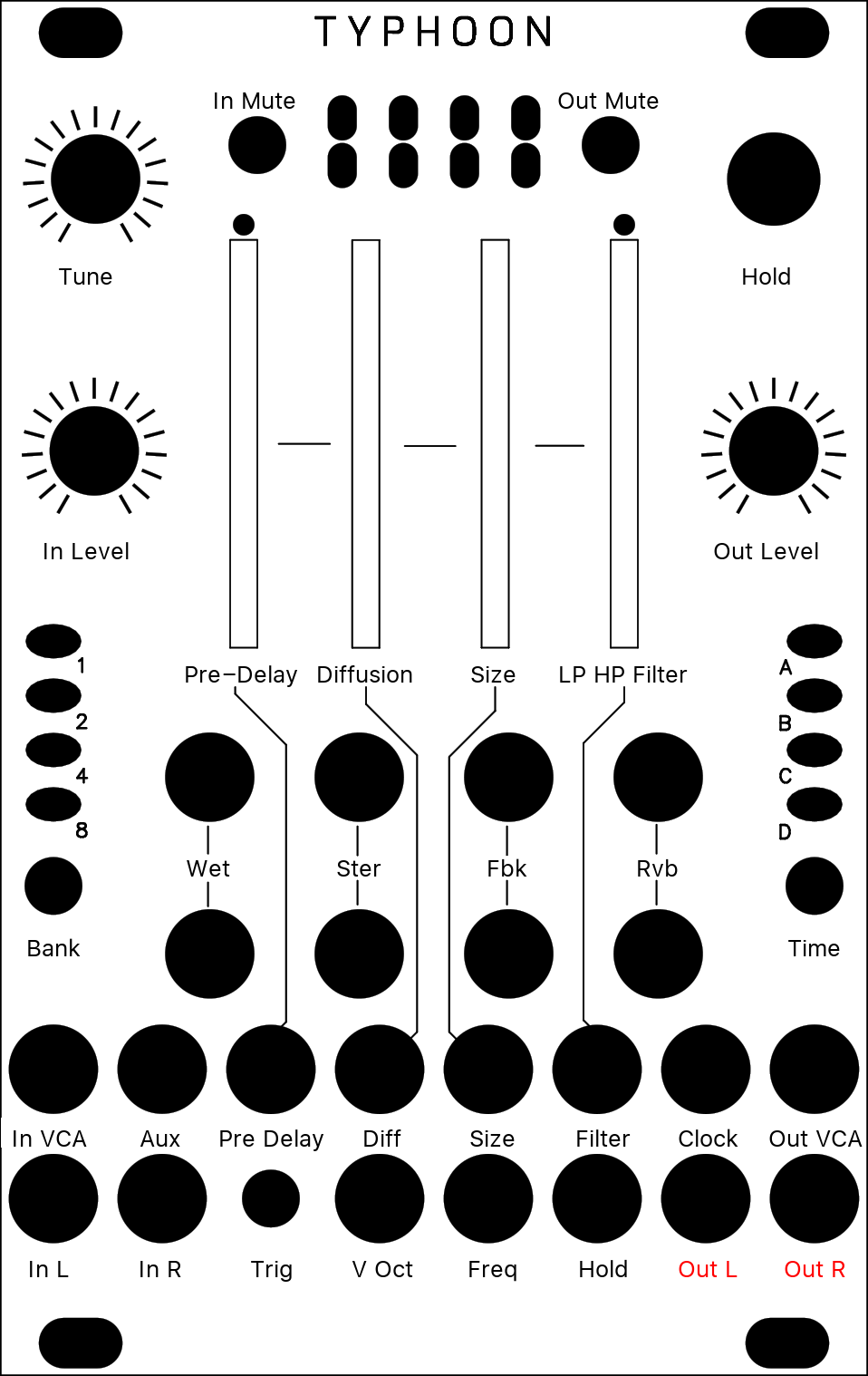
Mode 3 [○○●○]: Looping Delay (Parasites)
The looping delay mode continuously plays back audio from the buffer without any kind of granularization.
Source: mqtthiqs Parasites

Original Button | Parameter | Description
Position | Pre-Delay | Controls the distance between the playback head and the recording head (in other words, the delay time). Modulating POSITION will create effects similar to vinyl scratching or manual manipulation of tape.
Density | Diffusion | Creates a granular diffusion effect based on all-pass filters.
Size | Size | Controls the size of the overlapping windows used for pitch-shifting and time-stretching – from an extremely grainy “drilling” sound to smooth bits of loops.
Texture | LP/HP Filter | Acts as a low-pass/high-pass filter.
Hold | Hold | When FREEZE is activated, the content of the audio buffer is looped (stutter effect). POSITION controls the loop start and SIZE the loop duration. DENSITY creates a granular diffusion effect based on all-pass filters; and TEXTURE acts as a low-pass/high-pass filter.

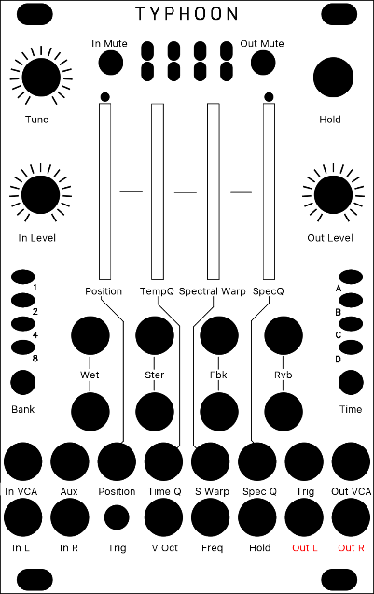
Mode 4 [○○○●]: Spectral Processor (Parasites)
In this mode, the incoming signal is converted into “frames” of spectral data, that are stored, transformed, recombined, and resynthesized as a time-domain signal.
Source: mqtthiqs Parasites

Original Button | Parameter | Description
Position | Position | POSITION selects into which buffer the audio is poured (when FREEZE is not active), or from which buffer the audio is synthesised (when FREEZE is active). For example, set POSITION to its minimum value. Press FREEZE. You get a first texture. Set POSITION to its maximum value. UNFREEZE. Wait for something else to happen in the incoming audio. Press FREEZE again. By moving POSITION you interpolate between the two textures which had been captured at the press of FREEZE. Depending on the quality settings there are 2 to 7 buffers laid out over the course of the POSITION knob. What the module does is crossfade between a “wavetable” of FFT slices.
Density | Tempo Quantisation | Determines how results from the analyzer are passed to the resynthesizer. Below 12 o’clock, there’s some increasing probability that a given FFT bin won’t get updated, causing a kind of partial freeze. After 12 o’clock, adjacent analysis frames are increasingly merged together (like a low-pass filter in the amplitude each frequency bin). At extreme settings, random phase modulation is applied to smooth things - giving you different flavours of spectral muddling/reverb.
Size | Spectral Warp | Changes the coefficients of a polynomial that determines how frequencies are mapped between the analysis and synthesis buffers. It’s like a 1-knob GRM Warp. Over the course of the knob it’ll do spectral shifting, but also spectral reversal.
Texture | Spectral Quantisation | Does two things: below 12 o’clock, it increasingly quantizes the amplitudes of the spectral components, like a very low-bitrate audio file. After 12 o’clock, it increasingly weakens the strongest partials and amplifies the weakest ones. This has the effect of making the spectrum more noise-like.
Trigger | Trigger | Sending a trigger to the TRIG input creates various frequency-domain glitches typical of corrupted (encoded) audio files. It works as a kind of build-up/feedback effect - the shorter the pulse, the smaller the effect. With a continuous gate, it’ll really start to rot…

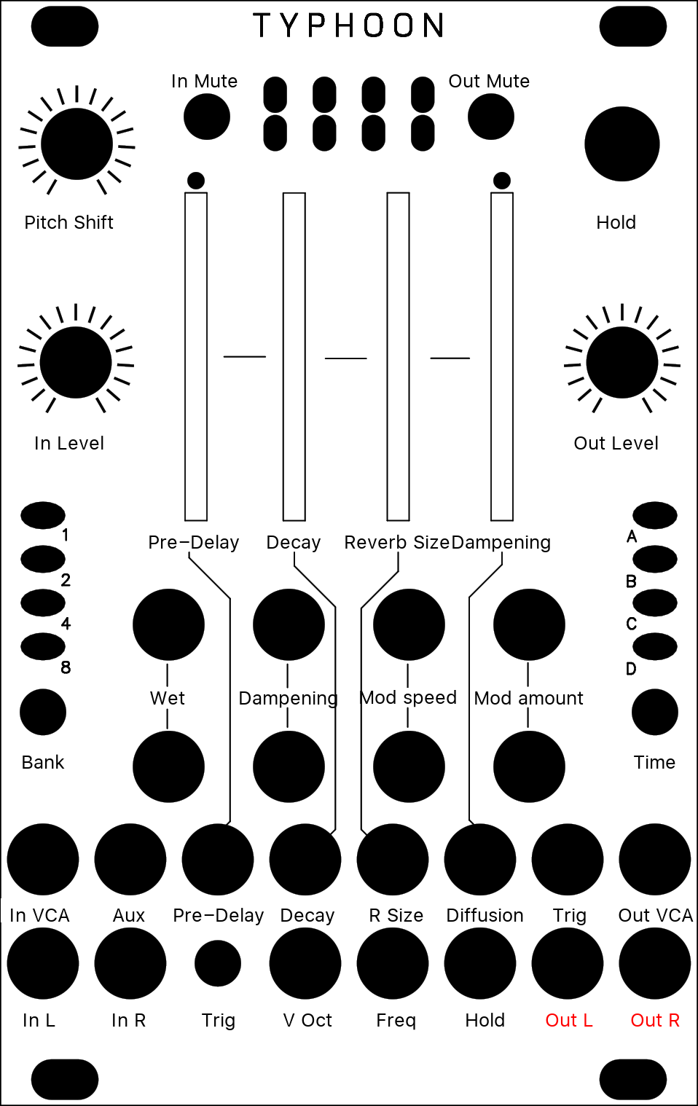
Mode 5 [○●●●]: Oliverb (Parasites)

A new, full-featured creative reverb mode based on the reverb of the original firmware (itself based on a description of the Lexicon 480L), and inspired in design by the Erbe Verb, with CV control over all parameters. It is largely modeless, probably unrealistic and goes far beyond your traditional reverb
Source: mqtthiqs Parasites
Original Button | Parameter | Description
Position | Pre-Delay | The Position knob controls the time it take for the reverb to kick in after a sound has gone in (from 0 to about half a second). When a clock is fed to the Trig input, this knob becomes a clock divider/multiplier for the pre-delay: at 12 o'clock, the pre-delay takes the value of the clock length; clockwise, this clock is divided, and counter-clockwise it is multiplied following the rates: 1/16, 3/32, 1/8, 3/16, 1/4, 3/8, 1/2, 3/4, 1, 3/2, 2/1, 3/1, 4/1, 6/1, 8/1, 12/1 (borrowed from the Echophon). Note that the clock division is limited to the largest division not exceeding the maximum delay; beyond this point, the Position knob will have no effect. Changing pre-delay in real time is smooth and does not affect pitch (it uses the internal time stretcher).
Density | Decay | The Density knob controls the amount of sound fed back into the reverb loop, i.e. the decay time of the reverb tail. Beyond 3 o'clock, this signal is actually amplified and the reverb enters self-oscillation.
Size | Reverb Size | The Size knob controls the lengths of all the delays internal to the reverb, i.e. the size of the emulated room. It varies from a small resonator to a huge hall.
Texture | Dampening | The Texture knob controls the dampening of the reverb. From fully CCW to 12 o'clock, a low-pass filter is applied, simultaing the absorption of the room. From 12 o'clock to fully CW, a high-pass filter is applied for unusual, crystalline effects.
Wet | Wet | The first function of the Blend knob is dry/wet crossfading, as in the other modes.
Stereo | Diffusion | The second Blend mode (called "stereo spread") controls how much the sound is "smoothened" by the diffusers each time it goes through the loop. Fully clockwise, you get the more dense, continuous sound; fully counter-clockwise, you clearly hear the sound being repeated like in a multi-tap delay.
Feedback | Modulation speed | The third function of the Blend knob (called "feedback") controls the speed of these LFOs. It ranges from ~1/100Hz to ~100Hz. It has no effect if modulation amount is null.
Reverb | Modulation amount | Each delay in the reverb can be individually modulated by 9 smoothed random LFOs. The fourth function of the Blend knob (called "reverb") controls the amount of modulation applied by the LFOs to the delay time. Small modulations result in subtle chorus and ghost tones, large modulations in random pitch shifts.
Tune | Pitch Shift | Each time the sound is fed back into the reverb, it can be pitch shifted. The Pitch knob controls, from -1 to +1 octaves how it is pitch shifted. At 12 o'clock, no pitch shifting is applied; fully clockwise, we get the classic shimmer effect; lots of oddities can be found in between. To hear the effect of the pitch shifter, some sound has to fed back by increasing Decay. Note that Size has an impact on how well the sound is pitch-shifted: the larger the room size, the more accurate the pitch shift.
Freeze | Freeze | The Freeze button sets reverb to (near) infinite decay, and mutes the input. This works best with no pitch shifting and a large size.

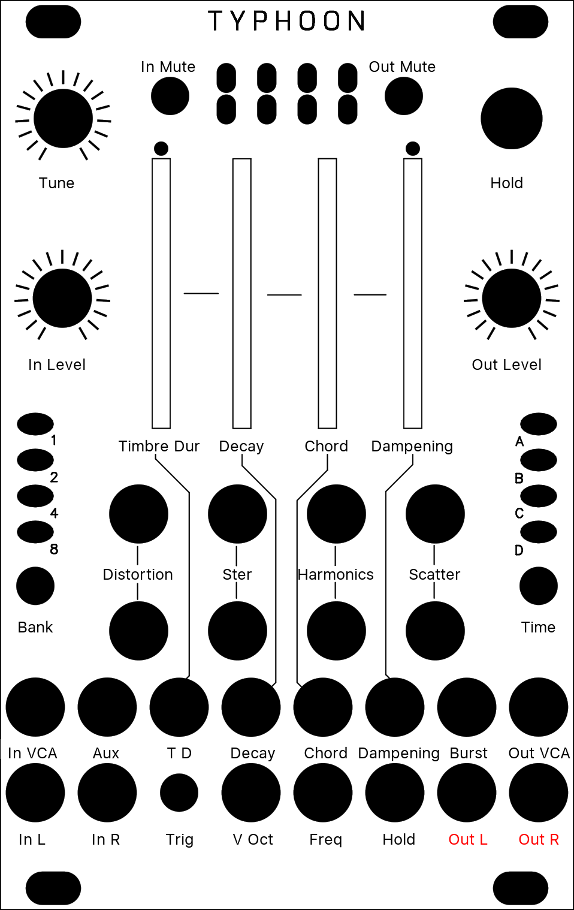
Mode 6 [●○●●]: Resonestor (Parasites)

It is a dual-voice, four-parts resonator (or comb filter) effect with built-in capability for polyphonic Karplus-Strong plucked string synthesis, and more. You access it by long-pressing the Blend button until LEDs become orange, and press it again several times until only the second LED is unlit (in other words, if LEDs 1, 3 and 4 are lit).
Source: mqtthiqs Parasites
Original Button | Parameter | Description
Position | Timbre Duration | Controls the timbre and duration of the noise burst. CCW, it will be longer and more dampened; CW, it will be shorter and more high pitched. At both ends of the knob, the burst will be inaudible (too damped or too short), which you can use to "mute" a voice.
Density | Decay | Decay time of the current voice. Beyond approx. 3 o'clock, decay is infinite and the sound sustains forever (you can use it as a traditional oscillator).
Size | Chord | Chord selection for the current voice. Morphs gradually between Unison, Fat, Superfat, Fat power, Fat octave, Octaves, Power, Major, Major7, Minor7, Minor, Sus2, Sus4, Minor9, Major9, Minor11, Major11, and Major11.
Texture | Dampening | Controls filtering in the feedback loop of the resonator. At 12 o'clock, no filtering is applied; CCW, a low-pass filter is applied with a increasingly low cutoff frequency; CW, a band-pass filter at the frequency of the resonator is applied with an increasingly high resonance.
Wet | Distortion | Randomly distorts the timbre of the voices by modulating each comb filter by low pass-filtered noise. Fully CCW, the modulation amount is maximum but the noise is filtered out entirely, so there is no effect. Fully CW, the noise is unfiltered, but the modulation amount is null, so there is no effect. In between, you get interesting effects, from subtle swaying to harsh distortion.
Stereo | Stereo | Assigns each part and voice to an output (Out L or Out R). Fully CCW, each voice goes to a different output. At 12 o'clock, both voices are equally mixed in both output. Fully CW, parts of both voices are distributed on both output for a wide stereo effect.
Feedback | Harmonics | Simulates striking the harmonics on a string. Fully CCW, it has no effect. Fully CW, the second harmonic will ring; at 12 o'clock, the third, at 10 the fourth etc.
Reverb | Scatter | Controls the random delay times before the sound (input or burst) hits each resonator of the current voice. Used for K-S synthesis with a chord, this will give the impression that strings are struck sloppily. The delay times are randomized at each voice switch.
Trigger | Burst | A trigger in this input will switch the current voice (if Freeze is not active) and send a short burst of noise in its resonator.
Hold | Hold | Switch the current voice, and inhibits further voice switch by the Trig CV.
Tune | Pitch | Base pitch of the current voice. At 12 o'clock, the pitch is A3 (220Hz).

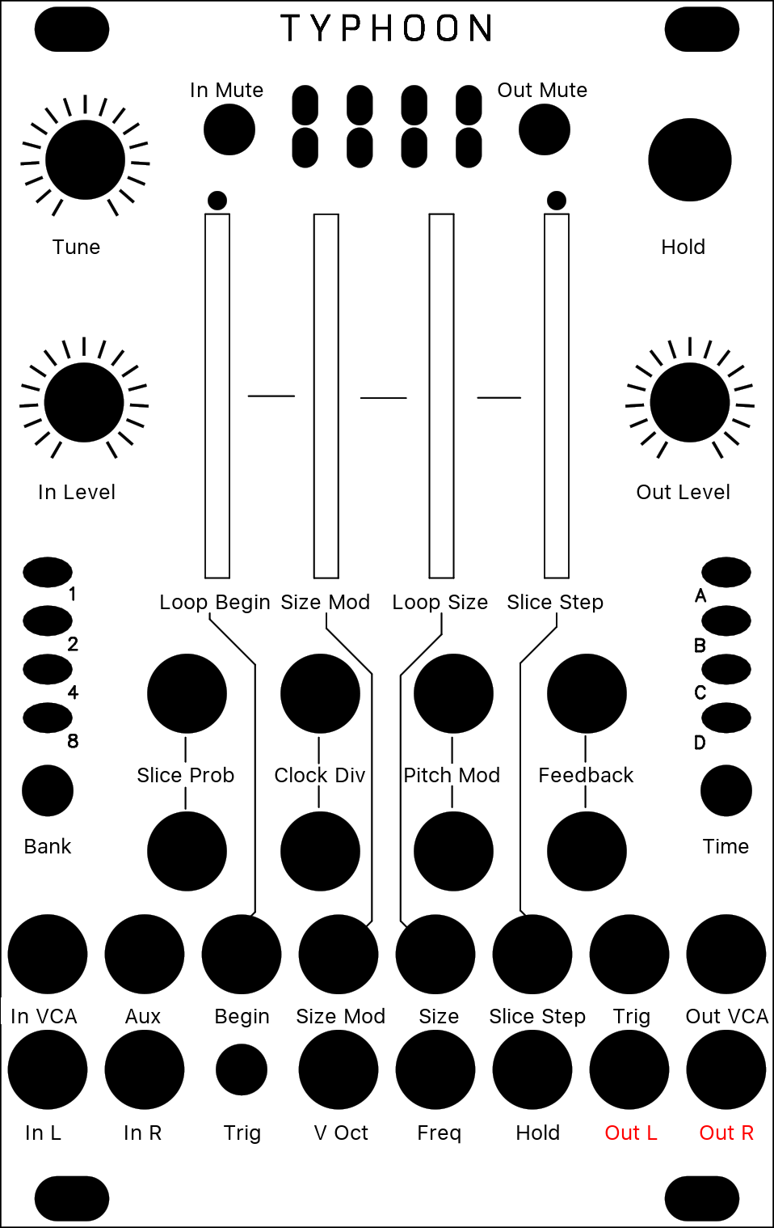
Mode 7 [●●○●]: Beat Repeat (Kammerl)
Note: This mode requires a clock signal plugged into the Trigger input. Without a clock signal, it holds the most recent slice (or outputs silence if no clock signal has been previously provided).
The Kammerl Beat-Repeat mode analyzes the incoming clock signal to enable real-time slicing of the audio input. It manages multiple slices in real-time which can be individually selected. Each slice can be played back with different loop, pitch and distortion settings.
Source: Kammerl Clouds

Original Button | Parameter | Description
Position | Loop Begin | Defines the beginning of the loop interval relative to the total slice duration. To support in-sync beat repetitions, it is quantized as follows: [0-1/64] free/unquantized, 1/64, 1/32, 1/16, 1/8, 1/4, 1/3, 1/2, 1.
Density | Loop Size Modulation | Enables a decreasing loop size towards the slice end. This enables a ping-pong bouncing ball effect: Tak tak tak taktak tatatatatttttttt
Size | Loop Size | Defines the size of the loop interval relative to the total slice duration as well as the loop mode (regular/alternating). To support in-sync beat repetitions, it is quantized as follows: Regular from the left to 12 o'clock: [0-1/64] free/unquantized, 1/64, 1/32, 1/16, 1/8, 1/4, 1/3, 1/2, Alternating from 12 o'clock to the right: 1/2, 1/3, 1/4, 1/8, 1/16, 1/32, 1/64, [1/64-0] free/unquantized
Texture | Slice Step | The Texture CV and the Slice Step control different slice selection parameters. The Texture CV directly selects one of the most recently recorded slices. In contrast, the Slice Step parameter selects individual iteration patterns to jump between slices during playback (which also incorporates the Texture CV slice selection by using it as an offset) Disabled - Only Texture CV selects slices - Slice step 1 - Repeats current slice due to synced playback index - Slice step 2 - Skips every second slice - Slice step 3 - Skips two slices - Slice step 5 - Skips four slices - Slice step 6 - Skips five slices - Slice step 7 - Skips six slices - Random - Randomly selects slices. CV: Selects one of the eight most recently recorded slices. 0V corresponds to the most recent slice (real-time / no delay!). Note that slices are continously created from audio input, independent from FREEZE or slice probability mode.
Wet | Slice Probabillity | Defines the probability of disabling bypass and processing an incoming slice. Note that activating the FREEZE button overwrites this setting.
Stereo | Clock Divider | Selects a clock divider: 1, 1/2, 1/4, 1/8 which changes the slice lengths accordingly.
Feedback | Pitch Mode | Selects one of four pitch modulation modes (from left to right): (left position) Fixed pitch - no modulation. Fixed pitch - reverse playback. Linearly decreasing pitch starting from the original pitch to the selected target pitch (Pitch Knob). Linearly increasing pitch starting from the the selected target pitch (Pitch Knob) to the original pitch. (right position) Simulated vinyl scratching - sinusoidal pitch modulation. The Pitch Knob defines the intensity.
Reverb | Feedback | Controls the contribution to Cloud's feedback path. Combined with lower pitch playback, this leads to amazing lazer gun effects on drums :)
Tune | Pitch | Defines the playback speed. The Kammerl Beat-Repeat mode does not time-correct the pitch changes (like a tape or record running at different speeds). This allows for interesting groove effects, since audio is delayed towards the end of the slice but reset at the slice beginning. To the very left, the knob defines a zero pitch, to the very right, the original playback speed. The pitch modulation is determined by the Pitch Mode knob.
Freeze | Freeze | Enables slice processing / beat-repeating. If not enabled, slice processing is randomly enabled based on the blend mode Slice Probability.

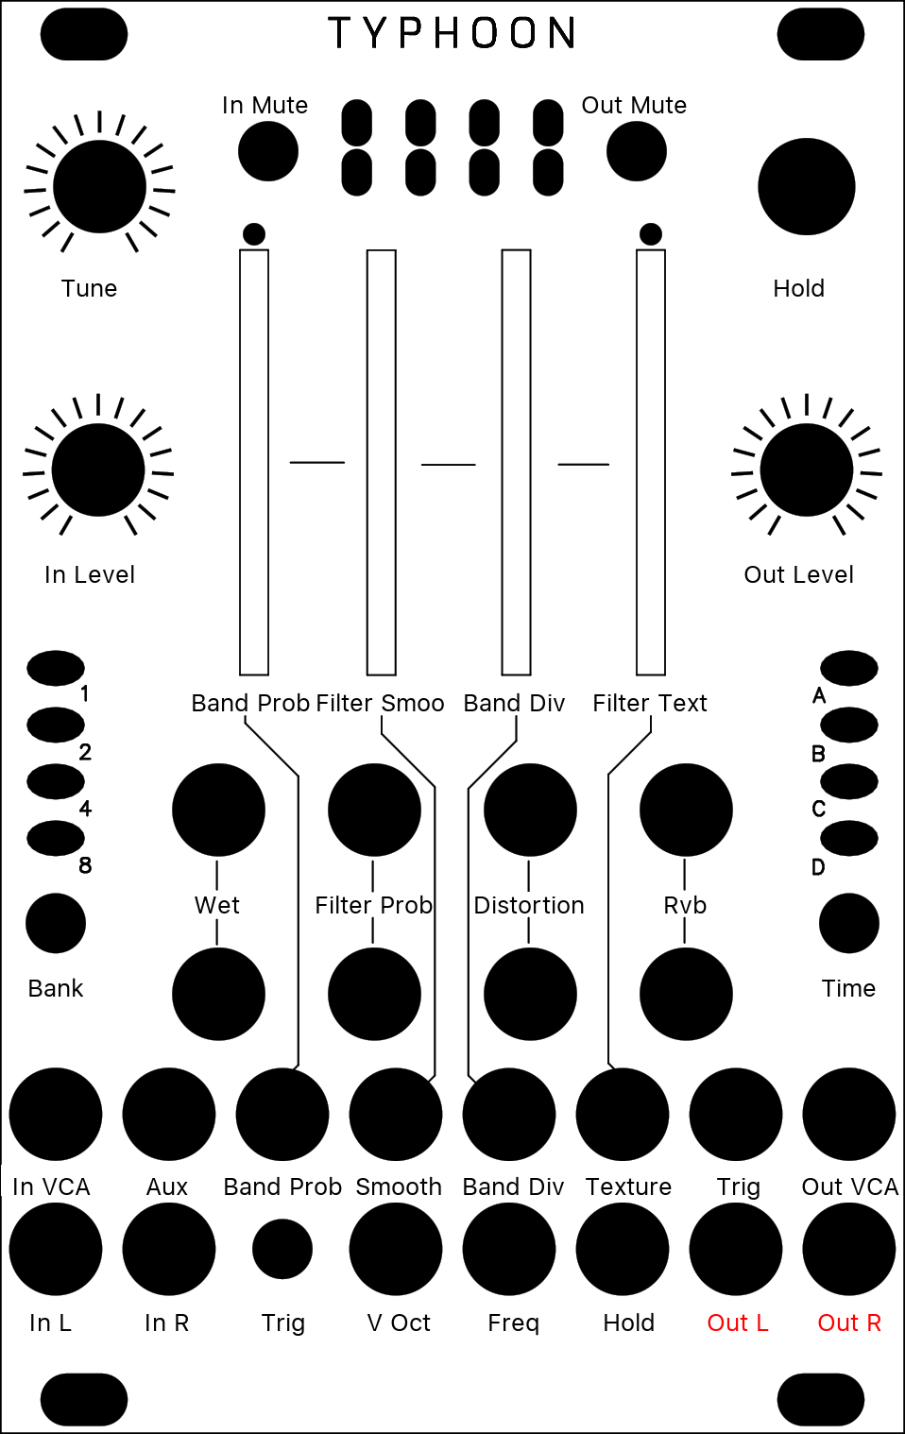
Mode 8 [●●●○]: Spectral Clouds (Kammerl)

The Spectral Clouds mode creates cloud-like frequency spectras. It is a high-resolution multiband filter with randomly modulated frequency bands. The logarithmic divisions of the frequency spectrum result in a continuously morphing but musical sounding filter. This mode is inspired by this FFT Randomizer project.
Source: Kammerl Clouds
Original Button | Parameter | Description
Position | Frequency band probability | Defines the probability of a frequency band to become enabled. To the left all frequency bands are disabled. Check out the sweet spot where only a few frequency bands are active.
Density | Filter Smoothing | Defines the smoothing intensity on the frequency band division as well as the filter band attenuation changes during "trigger input" events. To the left, filter changes are applied immediately; to the right, the current filter configurations is hold.
Size | Frequency band division | Controls the number of filter bands and their corresponding frequency width. To the left, the frequency spectrum is split into 4 filter bands and to the right into 128 filter bands. All frequency band divisions are applied in logarithmic scale to sound musical.
Texture | Filter texture | Defines the smoothing intensity on the frequency band division as well as the filter band attenuation changes during "trigger input" events. To the left, filter changes are applied immediately; to the right, the current filter configurations is hold.
Wet | Wet | Balance between input signal and Spectral Clouds output. Note that the warm distortion effect as well as Cloud's reverb is applied post dry / wet.
Stereo | Probability of random filter changes | Defines the chance of simulated "Trigger input" events. To the left, simulated trigger events are disabled and random filter reconfigurations only happen during high trigger input gates.
Feedback | Warm distortion | It's back :) Adds a warm sounding distortion effect (applied post dry/wet).
Reverb | Reverb | Controls the contribution to Cloud's reverb (applied post dry/wet).
Tune | Pitch | Pitch shifting applied to the Spectral Clouds output.
Trigger | Trigger | Randomizes the set of active frequency bands and defines their random attenuation intensity. Note that these trigger events can also be simulated with the second blend mode ("Probability of random filter changes").

